**Assignment – 3 Power BI**

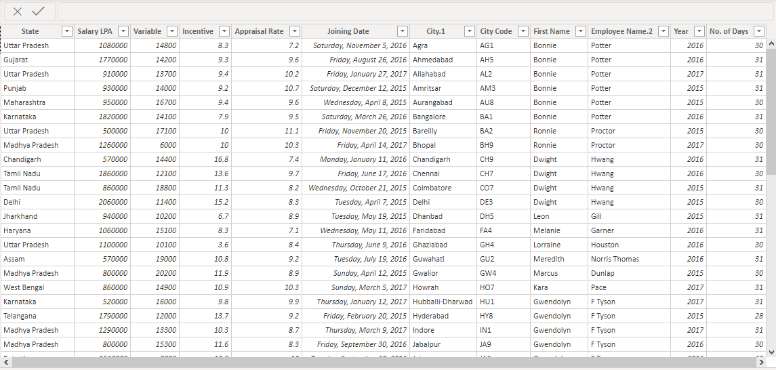

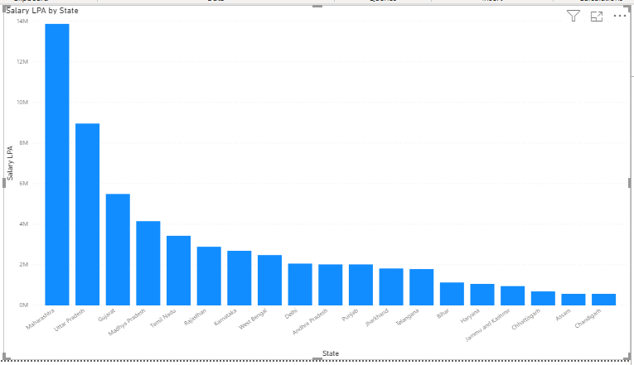

**Assam and Chandigarh have lowest payout.**